**Assignment 8**

**Data Science Masters**

**1) How-to-count-distance-to-the-previous-zero**

**For each value, count the difference of the distance from the previous zero (or the start**

**of the Series, whichever is closer) and if there are no previous zeros,print the position**

**Consider a DataFrame df where there is an integer column {'X':[7, 2, 0, 3, 4, 2, 5, 0, 3, 4]}**

**The values should therefore be [1, 2, 0, 1, 2, 3, 4, 0, 1, 2]. Make this a new column 'Y'.**

**import pandas as pd**

**df = pd.DataFrame({'X': [7, 2, 0, 3, 4, 2, 5, 0, 3, 4]})**

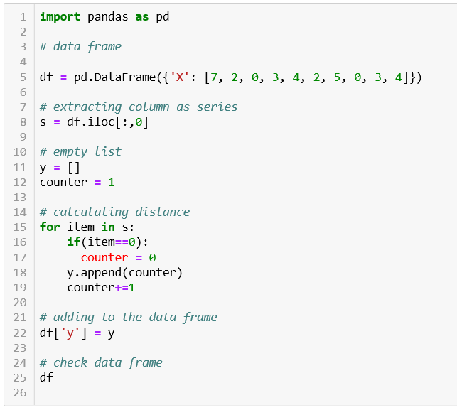

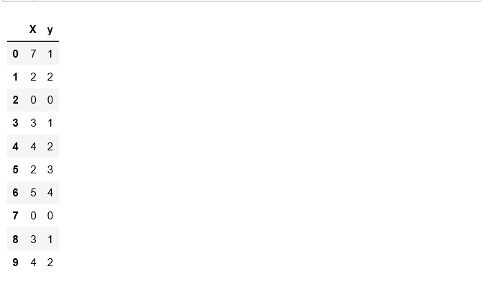

**2) Create a DatetimeIndex that contains each business day of 2015 and use it to index a**

**Series of random numbers.**

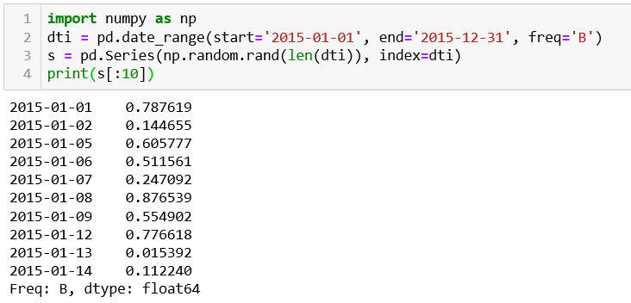

**3) Find the sum of the values in s for every Wednesday**

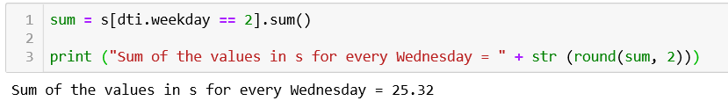

**4) Average For each calendar month**



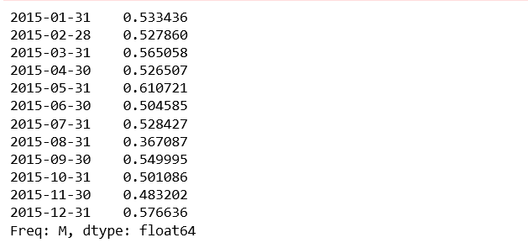

**5) For each group of four consecutive calendar months in s, find the date on which the**

**highest value occurred.**



